Automation testing on Cucumber

package steps definition;

import org.openqa.selenium.By;

import org.openqa.selenium.Keys;

import org.openqa.selenium.WebDriver;

import org.openqa.selenium.chrome.ChromeDriver;

import io.cucumber.java.en.And;

import io.cucumber.java.en.Given;

import io.cucumber.java.en.Then;

import io.cucumber.java.en.When;

public class Loginstep {

Web Driver driver=null;

@Given("user is on google search page")

public void user_is_on_login_page() {

System.*out*.println("user is on google search page");

String projectpath=System.*getProperty*("user.dir");

System.*out*.println("Project path is:"+projectpath);

System.*setProperty*("webdriver.chrome.driver", projectpath+ "\\src\\test\\resources\\driverschrome\\chromedriver.exe");

driver=**new** ChromeDriver();

driver.navigate().to("https://google.com");

}

@When("user enters a text in box")

public void user_is_on_google_search_page() {

driver.findElement(By.*name*("q")).sendKeys("Automation step by step");

}

@And("hits enter")

public void hits_enter() {

driver.findElement(By.*name*("q")).sendKeys(Keys.ENTER);

}

@Then("user is navigated to the search results.")

public void user_is_navigated_to_the_search_results() {

driver.getPageSource().contains("online course");

driver.close();

driver.quit();

}

}

Features of Cucumber

Feature: feature to test google functionality

Scenario: valid google search is working

Given user is on google search page

When user enters a text in box

And hits enter

Then user is navigated to the search results.

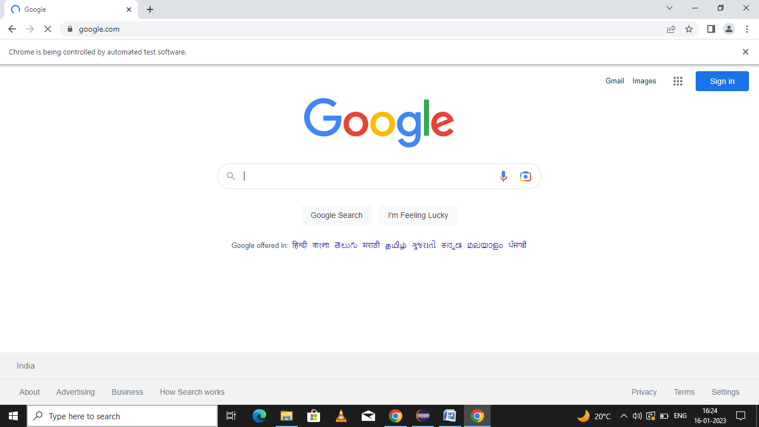Screenshots of Cucumber: